Install the Tesseract OCR

- https://github.com/tesseract-ocr/tesseract Download page

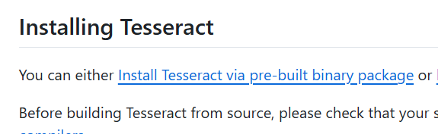

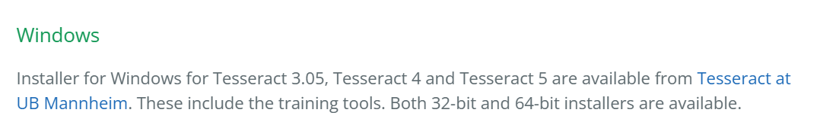

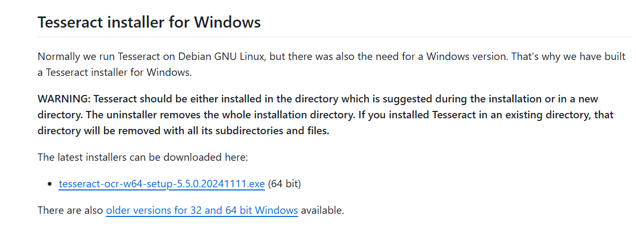

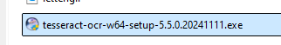
- Install this program.

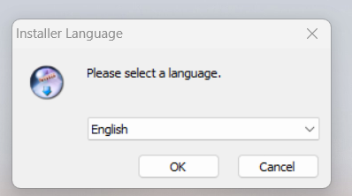

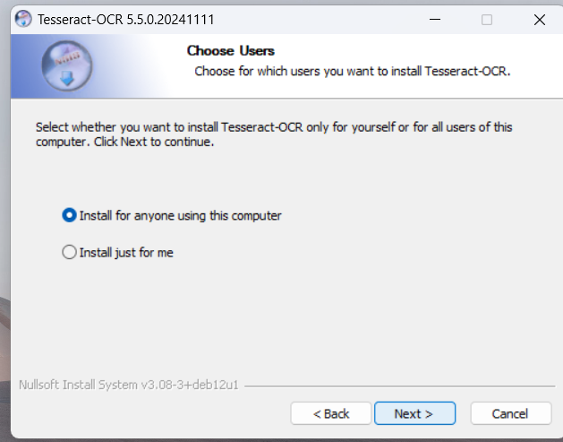

Next – Next -- Install

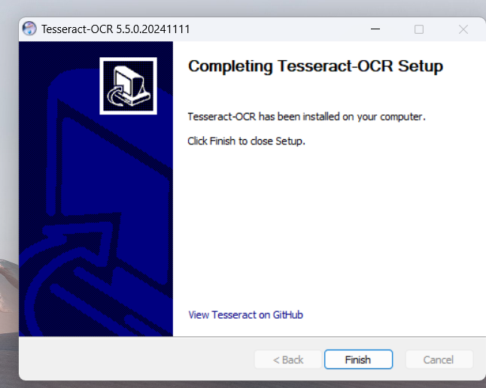

- We should describe its’ path. Go search bar and write “Environment Variables”
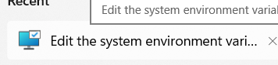

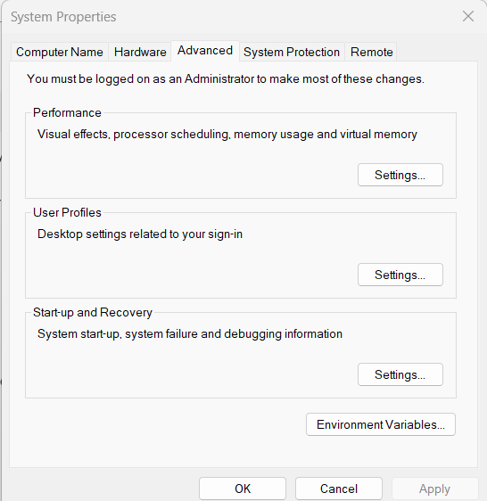

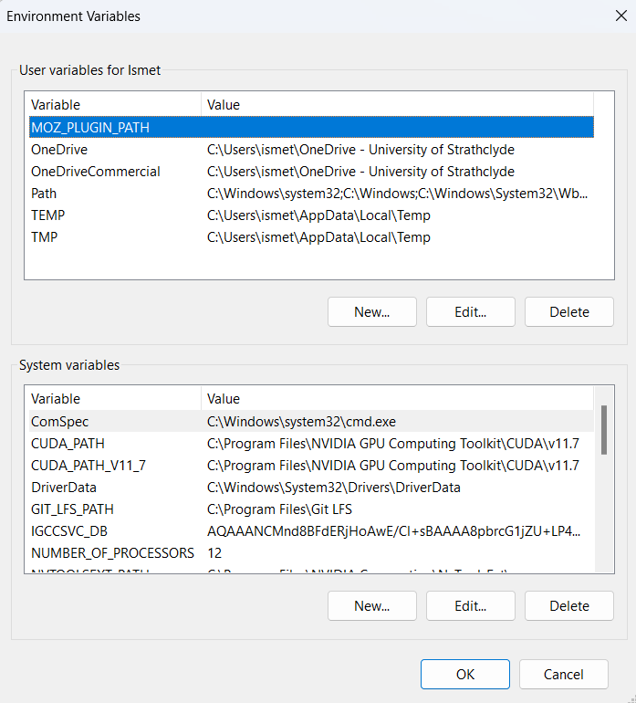

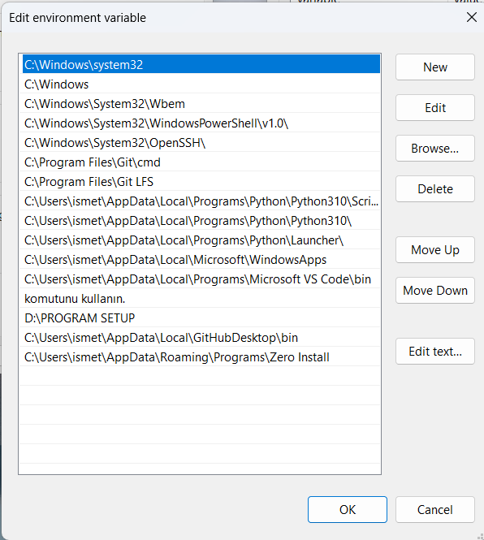

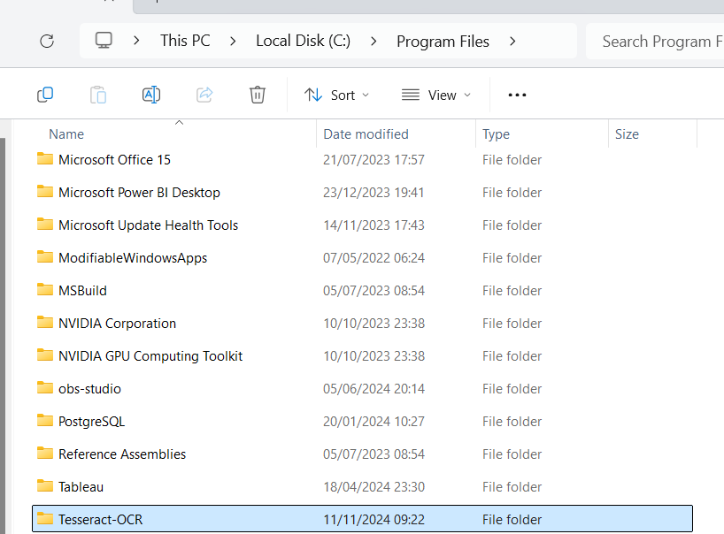
- We need detect Tessaract’s path. Go to This Computer and find Tesseract Folder

- Open it and copy its’ path like this “C:\Program Files\Tesseract-OCR”

- Turn again to “Edit environment variable” and paste your path here:
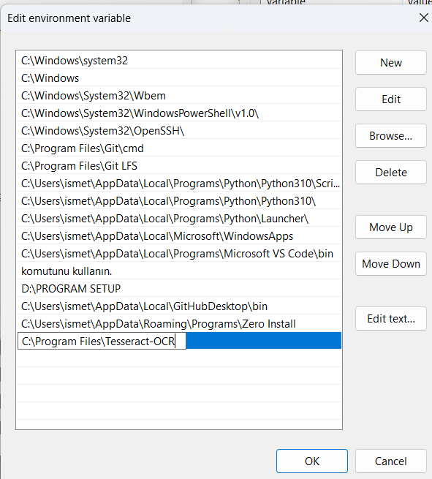

- Turn to Notebook and enjoy….

